Problem Set 4 Testing

Graph interface during game play:

Testing of small sample data set.

Output of commands u, i, p, and s are shown.

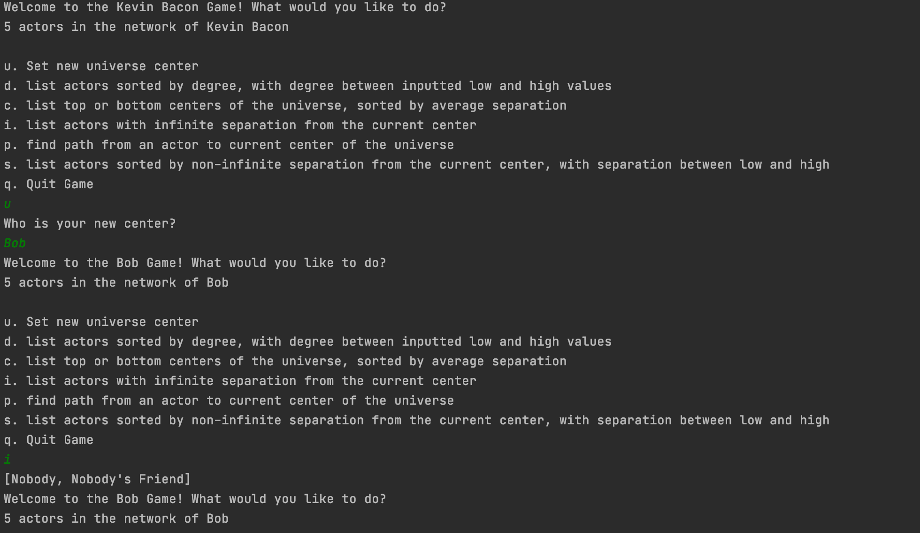

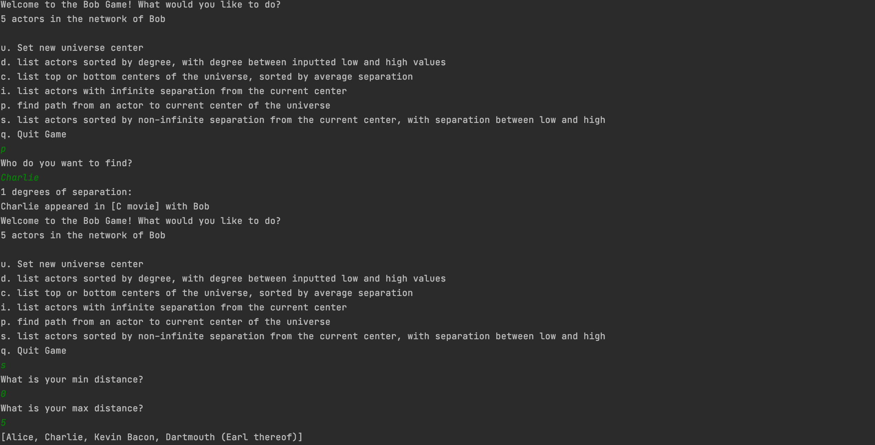

Testing of large movie-actor data set.

Output of commands c and d are shown.  


Graph constructed from sample data set:



**Good and Bad Bacon Recommendations**

Our good and bad Bacon recommendations in terms of degree showed that the best Bacons were Robert de Niro and Gene Hackman who both have a degree between 100 and 120. Our worst Bacons include Geraldo Rivera, Debra Eisenstadt, Leonard Paltier, Spencer Aste, Pierre Arditi, Barry Yourgrau, and Jamaica Kincaid, who all have a degree between 0 and 1. In comparison, Kevin Bacon has a degree of 80, so our method was successful in sorting good Bacons from bad Bacons.

Our good Bacon recommendations in terms of average separation were Gene Hackman, Robert de Niro, Robert Duvall, Sean Connery, and Michael Caine. Our bad Bacon recommendations in terms of average separation were Nita Naldi, John Longden, Charles Paton, John F. Hamilton, and Sara Allgood. In comparison, in the good Bacons group, Gene Hackman has an average path of 3.06, which is better than Kevin Bacon’s average separation of 3.28, and in the bad Bacons group, Nita Naldi has an average path of 8.68, which is much worse than Kevin Bacon’s.